AODV Simulation Results

Ad-hoc Simulations and Resilience

The recovery of network pathways is an often studied aspect of the resilience of network protocols. Using ad-hoc networks is one method of recovering packet paths after an interruption of the network topology. One particular routing algorithm of interest is the Ad-hoc On-demand Distance Vector (AODV) routing. Its distinguishing feature is that it sends de-centralized route requests (RREQ) that seeks to reconnect to the established path. In doing so, it allows each node to build a set of potential re-connections, thus allowing it to choose the shortest one.

Our objective is to simulate the behavior of several mobile ad-hoc networks (MANETs) under the AODV protocol. We also show how these evolutions change the packet transmission rate of our network. This is due to both the increased time required to re-connect network pathways, as well as the failure to reconnect those pathways at all. We will be regularly sending packets from some source to a sink, and monitoring their progress. This includes statistics like packet transmission speed, packet transmission rate, and last successfully sent packet.

We propose several experiments to test the ability of ad-hoc networks to recover a network pathway from one node to another. This will be done on two network topologies: the Grid Topology, and the Constant Velocity Topology. The Grid Topology experiment will test the AODV protocol’s performance when nodes are disabled in a topology. The Constant Velocity Topology seeks to test AODV’s performance when nodes are in motion. We perform multiple sets of experiments on each topology to gauge AODV’s performance under a variety of initial parameters.

AODV Grid Topology
Our first illustration of the AODV protocol is a 5x10 grid. Each node is separated from its grid-wise neighbor by the same distance. For each of our future Grid Topology simulations, let us denote node 0 as the packet source and node 49 as the sink. In our construction, node 0 is located at the top left of the landscape, while node 49 is located at the bottom right.

The packet transmission scheme will be as follows. Let us denote the distance between nodes as x meters. In the first second, a packet is sent from node 0, at position (0,0), to node 49, at position (9x, 9x). After the first second, node 1 is moved outside of effective range of our network topology, to the point (20x, 20x). The first iteration of the evolution is seen as below, for x=30 meters.

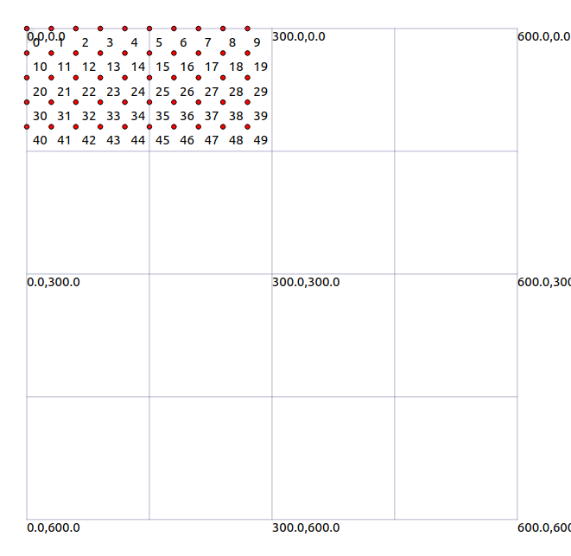
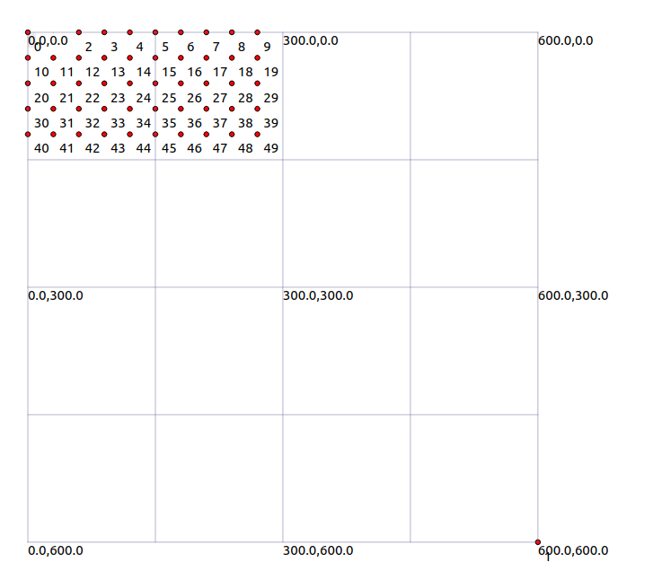

The packet size is 1024 bytes, and the transmission power is 16.02 dBm (decibel milliwatts).
During second 2, another packet is sent from the source to the sink. Afterwards, node 3 is moved out of effective range to the position (20x, 20x). This is repeated for 24 more iterations, with every other node being removed from the topology. This experiment is denoted as “1 node.”

We perform two more variants of this experiment. In the variant denoted “2 nodes,” for each iteration k, we move nodes 3k+1, 3k+2. For this variant, we perform 19 iterations.

In the variant denoted “3 nodes,” for each iteration k, we move nodes 4k+1, 4k+2, 4k+3. There are 12 iterations for this variant.

These variants introduce larger gaps in the topology per iteration, stressing the AODV protocol to a larger extent and highlighting the algorithm’s ability to search for alternate routes. Below are a few example topologies of the various variants.

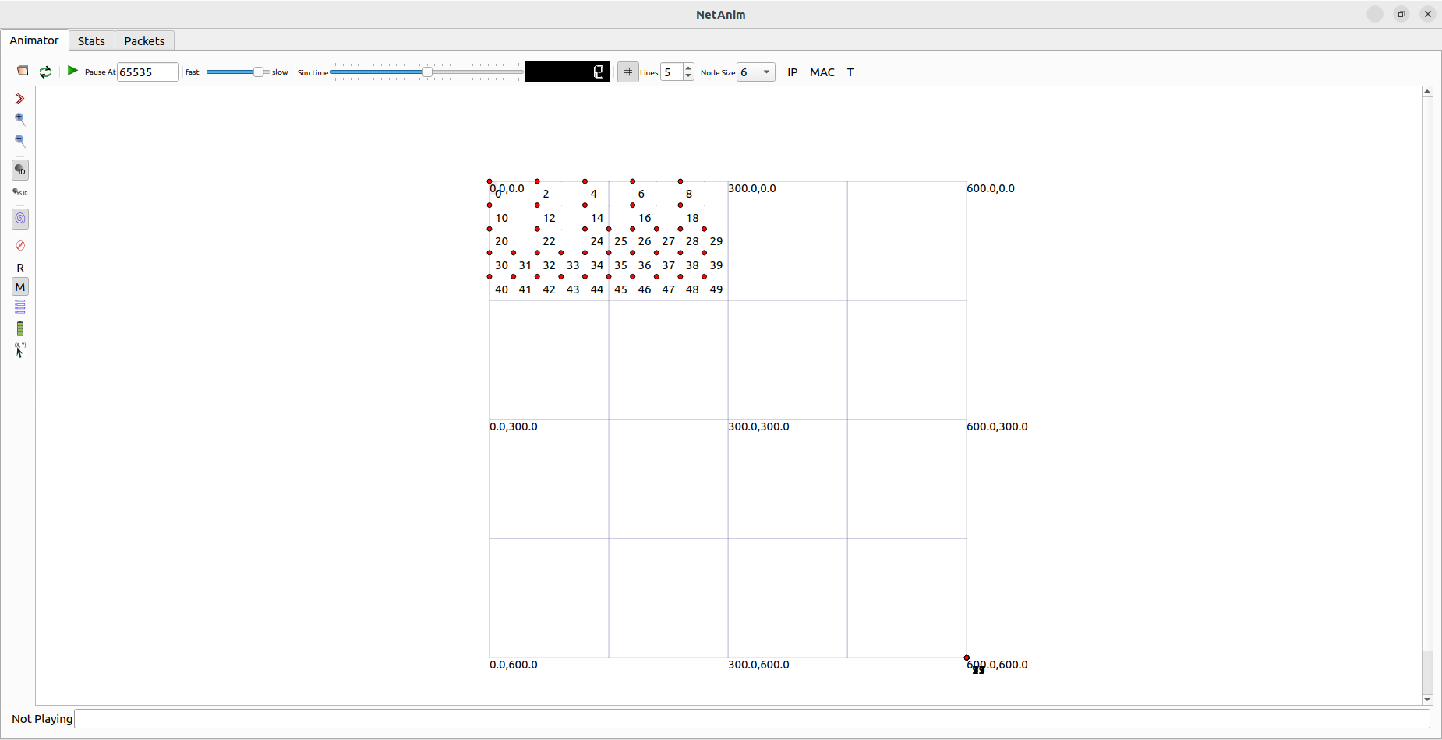
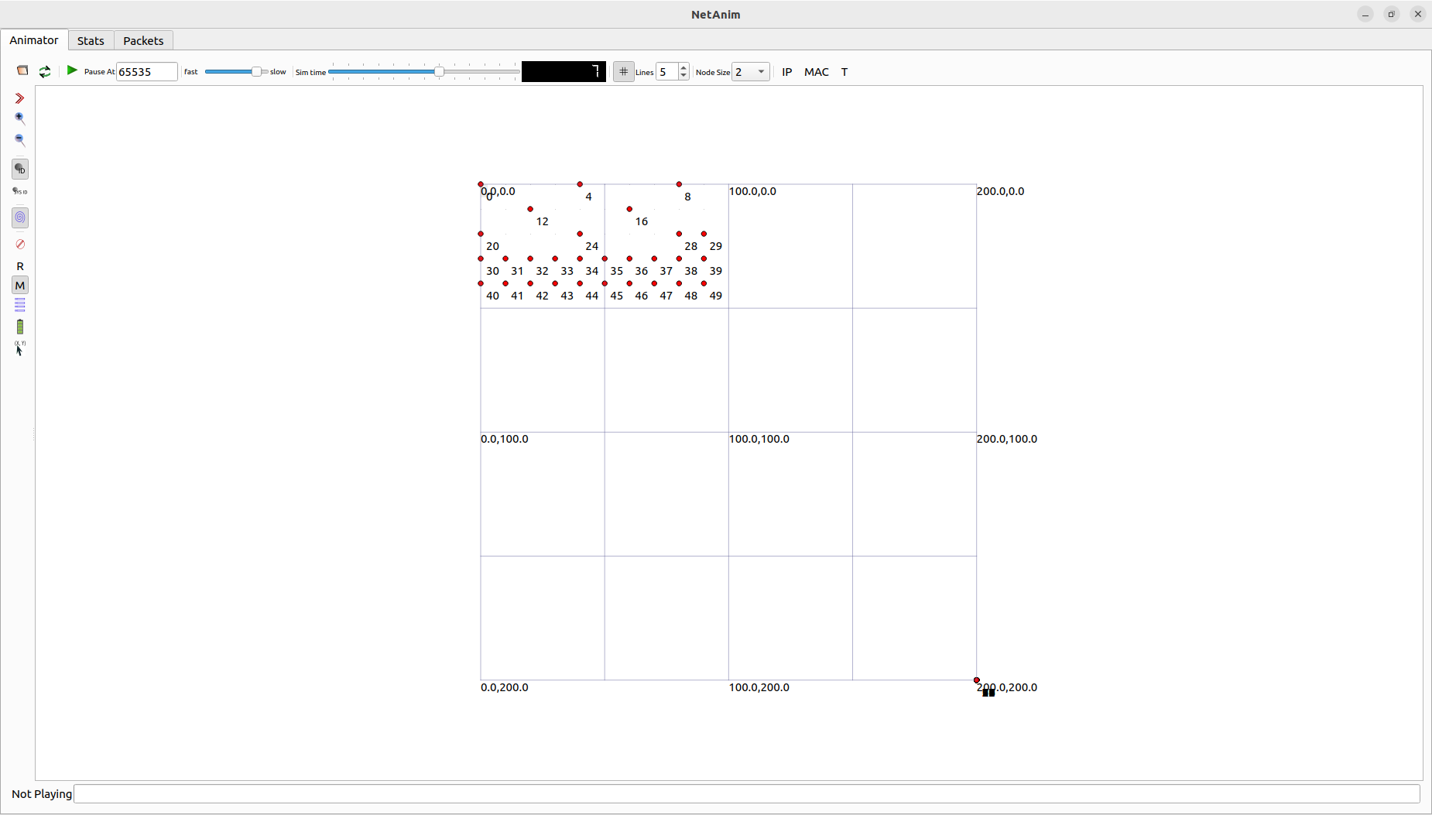
1 node variant topology 3 nodes variant topology
AODV Path Recovery Data
We will now quantify the ability for the AODV protocol to recover paths after disturbances to the topology. For illustration, consider the 1 node experiment. Suppose that after n iterations where a packet is successfully sent from the source and received by the sink, no more packets can reach the sink. We will define the packet reception rate as .

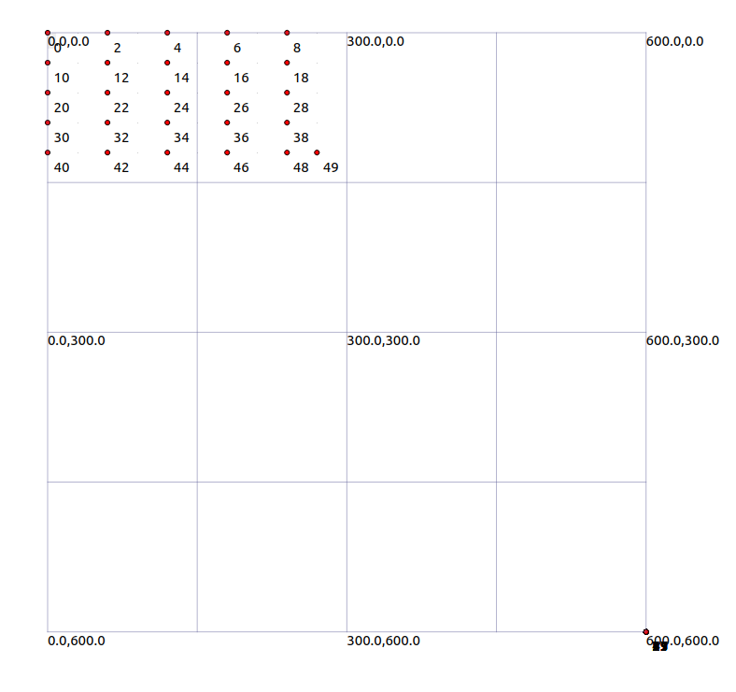
For example, if the packet reception rate is 1, then the path from source to sink is successfully preserved as nodes are removed until we are left with the reduced topology below.

As a result, the packet reception rate can quantify the ability of AODV to compensate for an evolving topology. That is, if the packet reception rate is high, then AODV performs very well in recovering paths for that system. If the packet reception rate is low, then AODV performs very poorly.
AODV Grid Topology Evolution Results

We simulated the AODV protocol on our evolving topology, with several varying parameters. We then measured the Packet Reception Rate of that AODV simulation. We changed the distance between nodes to highlight the difficulty of repairing connections as they grow further apart. We then repeated the experiments for the 1 node, 2 nodes, and 3 nodes variant.

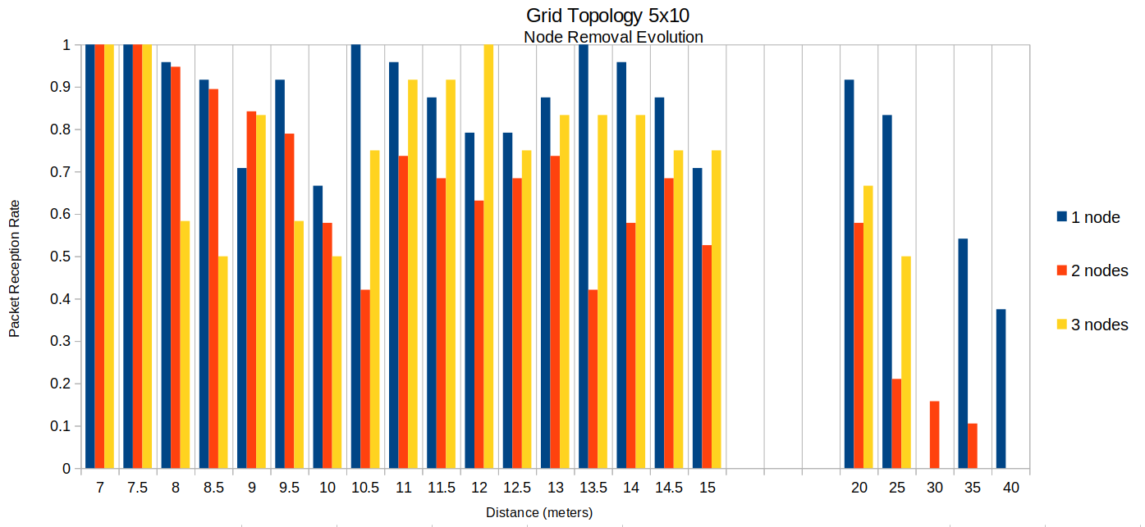
There are several patterns in the data that are noteworthy. We see that in general, the larger the distance between nodes, the smaller the packet reception rate. Therefore, the AODV protocol becomes more unstable. We also see that in general, the “1 node” variant is more stable than the “2 node” or “3 node” variant. Finally, as the distance between nodes gets too large, the packet reception rate trends sharply to 0 as the AODV protocol can no longer cope with the increasingly large distances between nodes.

Interestingly, we notice that there is an area of relative stability between the distance values of 10.5 and 14.5. This may be due to the intermediate paths found using AODV being more robust to subsequent interruptions. Further investigation of the path evolution while the topology changes is required.

AODV Variable Power Grid Topology Evolution Results

To complement the realism in the simulation, we introduce an additional variable, WIFI power. Previously, we had set the transmission power as the default, 16.02 dBm (decibel milliwatts). We now set the transmission power as 10,000 dBm. Similarly, we increase the distance between nodes by a magnitude of 10. We see the results of the simulation below.

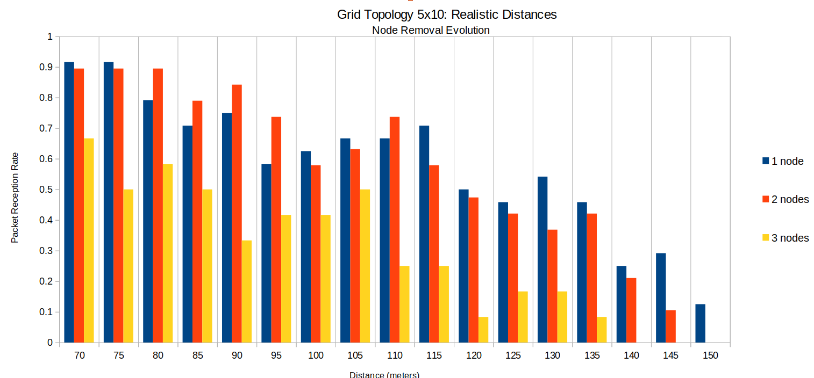

We see similar behaviors for the realistic distances model as the previous graph. However, one additional observation is that the area of relative stability is much less pronounced. That is, the gradual decrease in AODV stability is much smoother in the realistic distances model. This may be explained by the fact that it is easier to recover paths with a higher WIFI power level. This means that a poorly chosen intermediate path is less fatal to the ability of subsequent paths to cope with the evolving topology. Again, further investigation into the exact paths chosen by algorithm is necessary.
AODV Constant Velocity Model
